|  |  |
| --- | --- |
|  | **Project Design Phase-II Technology** |
|  | **Stack (Architecture & Stack)** |
|  |  |
| Date | 31 October 2022 |
|  |  |
| Team ID | PNT2022TMID49645 |
|  |  |
| Project Name | Classification of Arrhythmia using Deep Learning with 2-D ECG Image |
|  |  |

**Technical Architecture:**

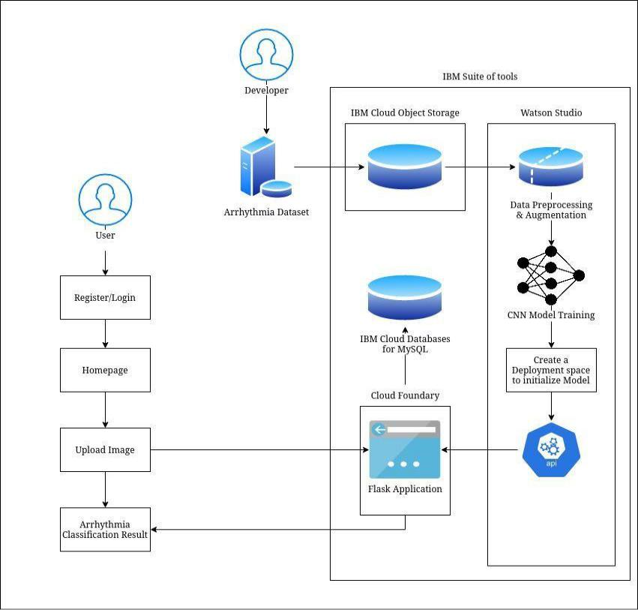

**Table-1 : Components & Technologies:**

|  |  |  |  |  |  |  |  |  |  |
| --- | --- | --- | --- | --- | --- | --- | --- | --- | --- |
| **S.No** | **Component** | | **Description** | |  | **Technology** | | |  |
|  |  |  |  |  |  |  |  |  |  |
| 1. | User Interface | | How user interacts with application e.g. | |  | HTML, CSS, Flask | | |  |
|  |  |  | Web UI, Mobile App, Chatbot etc. | |  |  |  |  |  |
|  |  |  |  |  |  |  |  |  |  |
| 2. | Application Logic-1 | | Data preprocessing and data augmentation | |  | Python, ImageDataGenerator Library | | |  |
|  |  |  |  |  |  |  |  |  |  |
| 3. | Application Logic-2 | | Training the model | |  | Python, CNN | | |  |
|  |  |  |  |  |  |  |  |  |  |
| 4. | Application Logic-3 | | Access the model deployed in Watson studio | |  | IBM Watson, Flask application | | |  |
|  |  |  | using created API key | |  |  |  |  |  |
|  |  |  |  |  |  |  |  |  |  |
| 5. | Cloud Database | | Database Service on Cloud | |  | IBM cloud databases for MySQL | ,IBM | |  |
|  |  |
|  |  |  |  |  |  | cloud object storage,etc. | | |  |
| 6. | Machine Learning Model | | To classify Arrhythmia | |  | CNN, Numpy,pandas, matplotlib, | | |  |
|  |  |  |  |  |  | ImageDataGenerator, OpenCV | | |  |
| 7. | Infrastructure (Server / Cloud) | | Application Deployment on Local System / Cloud | |  | Local, Cloud Foundry,IBM watson | | |  |
|  |  |  |  |  |  |  |  |  |  |
| **Table-2: Application Characteristics:** | | |  |  |  |  |  |  |  |
|  |  |  |  |  |  | | |  |  |
| **S.No** | **Characteristics** |  | **Description** |  | **Technology** | | |  |  |
|  |  |  |  |  |  | | |  |  |
| 1. | Open-Source Frameworks |  | List the open-source frameworks used |  | Tensorflow | | |  |  |
|  |  |  |  |  |  | | |  |  |
| 2. | Security Implementations |  | Limit direct acces to deploy model |  | IAM Tokens(API key). | | |  |  |
|  |  |  |  |  |  | | |  |  |
| 3. | Scalable Architecture |  | AutoScaling our service |  | Cloud Foundry | | |  |  |
|  |  |  |  |  |  | | |  |  |
| 4. | Availability |  | high availability and disaster recovery |  | Cloud Foundry | | |  |  |
|  |  |  |  |  |  | | |  |  |
| 5. | Performance |  | handling multiple request & distribute traffic in an |  | Cloud Foundry | | |  |  |
|  |  |  | optimal way |  |  |  |  |  |  |
|  |  |  |  |  |  |  |  |  |  |